**159. Child Routes: Challenge**

* -: As mentioned at the end of the last lecture, the next goal is to implement child routing for our recipe routes here, so that when we click a recipe here, we actually load it by adding, let's say slash, and then the idea of that recipe in our recipes array here in the URLs.
* Recipes one would load the first element or recipes zero actually since we started zero in the array and so on.
* So that would be great if we could load our recipes like that and render them here then.
* So with a child router again, and the same for new recipe and add it, but, for that, we will need a new component.

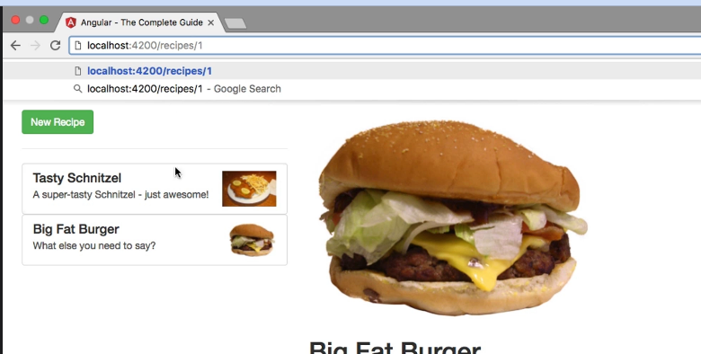

* Let's implement this in a second step.
* The first step should be to make these items clickable and load the detail component as a child route here in a new router outlet probably.
* We will also need another new component then, for the case that we first visit our page.
* In this case, we should have a starting component which kind of says, "Please select the Recipe!" Something we right now do by displaying this template here in our recipes component here, the NG template, but that will then also be removed because all I want to have inside of this div with the call MD7 class here is our router outlet.
* So, again, this is a challenge for you.
* Try implementing this child routing, or at least try to do the first steps of that.
* Setting up the router, creating that component which basically says, "Please select a recipe!", and then loading either that component or the detail route, the detail component, depending on whether we click the recipe in the list or not.
* Certainly a challenge, but also something where you can practice a lot of the things we learned in the last lectures.
* Starting in the next lecture, we will do this together, so then you can see my approach on implementing this.